Fltterning json data 5

Dataset 6= emp_details_5

[

{

"id":"101",

"name":"srinivas",

"gender":"male",

"address":{

            "city":"Hyderabad",

            "country":"india",

            "house_dtls":{

                            "doorno":"1-2-3",

                            "street":"srnagar"

                         }

          }

},

{

"id":"102",

"name":"phani",

"gender":"male",

"address":{

            "city":"Hyderabad",

            "country":"india",

            "house_dtls":{

                            "doorno":"1-2-3",

                            "street":"ameerpet"

                         }

          }

}

]

1. Create source similarly as previous one

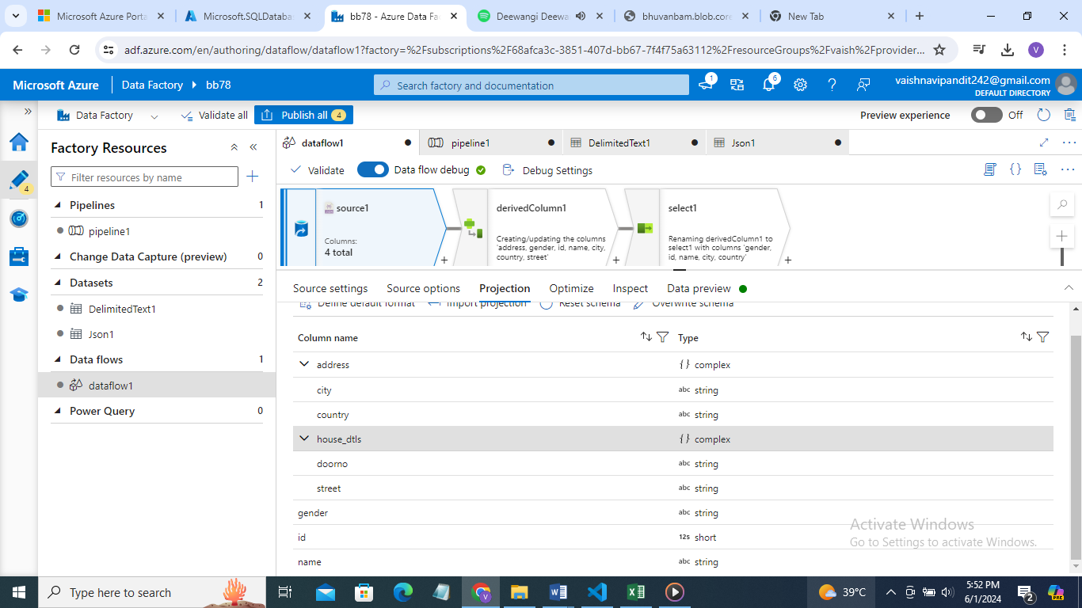

1. Now create derived column

Add columns for address.city, address.country, address.house_dtls.doorno, address.house_dtls.street

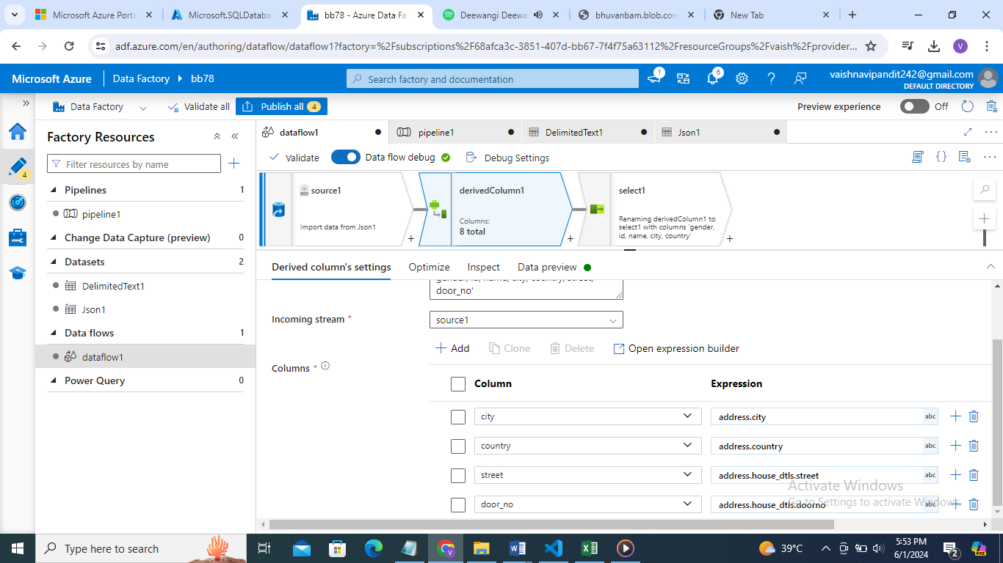

1. Now see preview

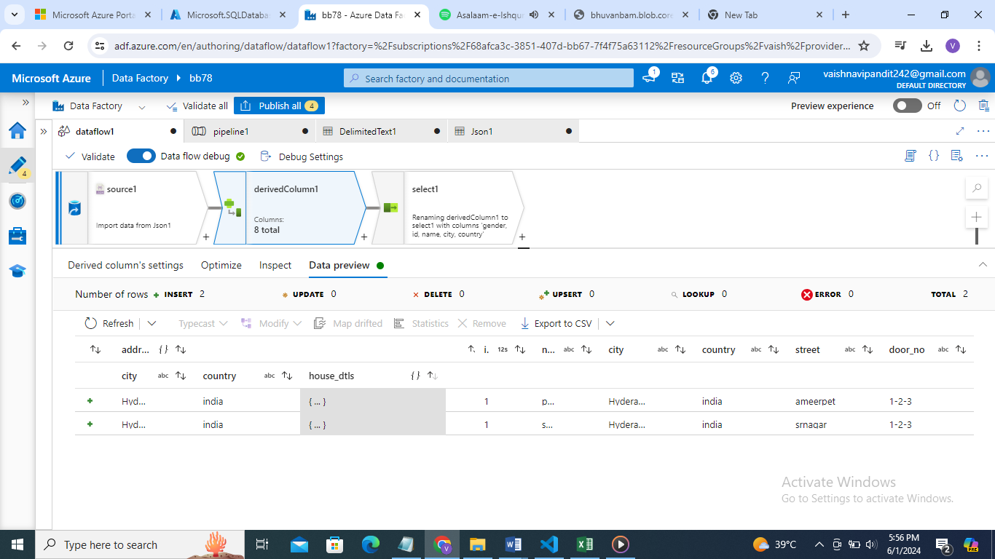

1. Now we need to more flattern it remove column address
2. Create select and delete address

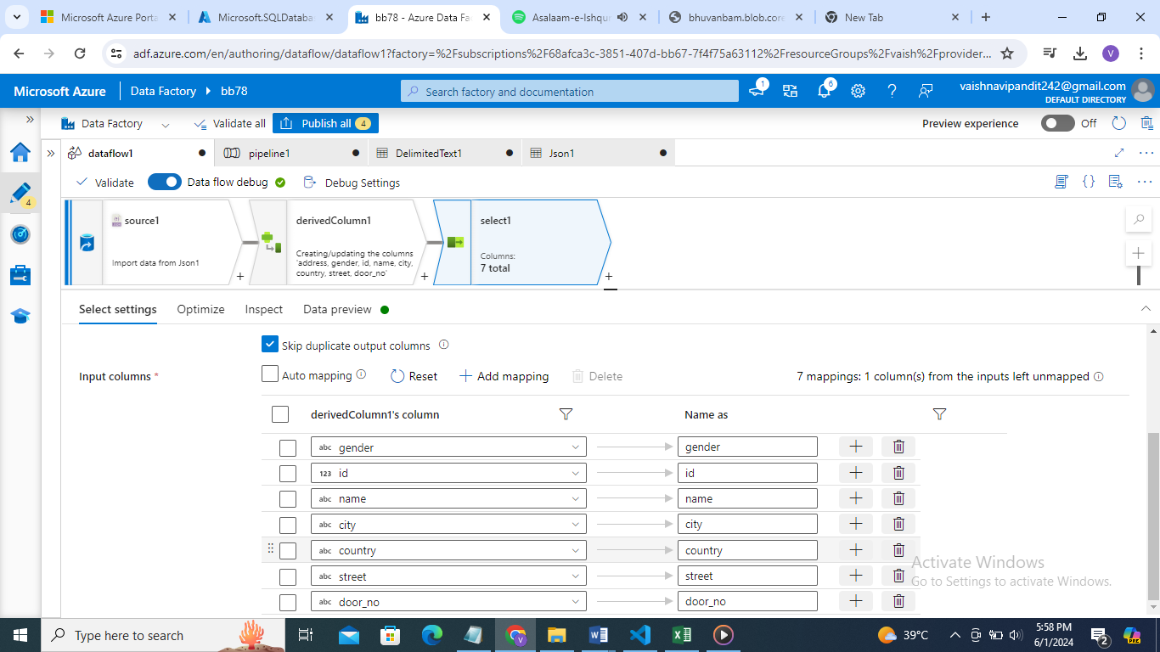

1. Now see data preview

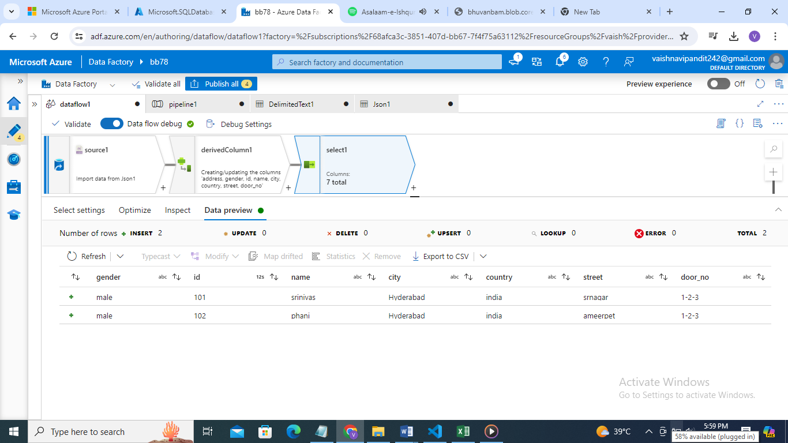

1. Now if we want to save this as a teble in azure sql database then

Add sink and add dataset for sql database in azure

1. Go to sink new dataset->azure database->linked service->in linked service select legacy instead of recommended->select new table->add table name

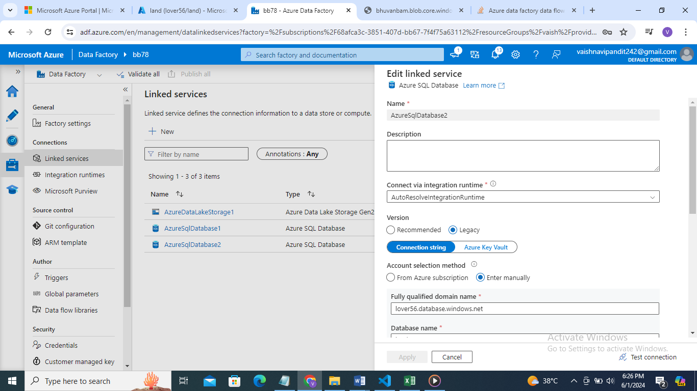

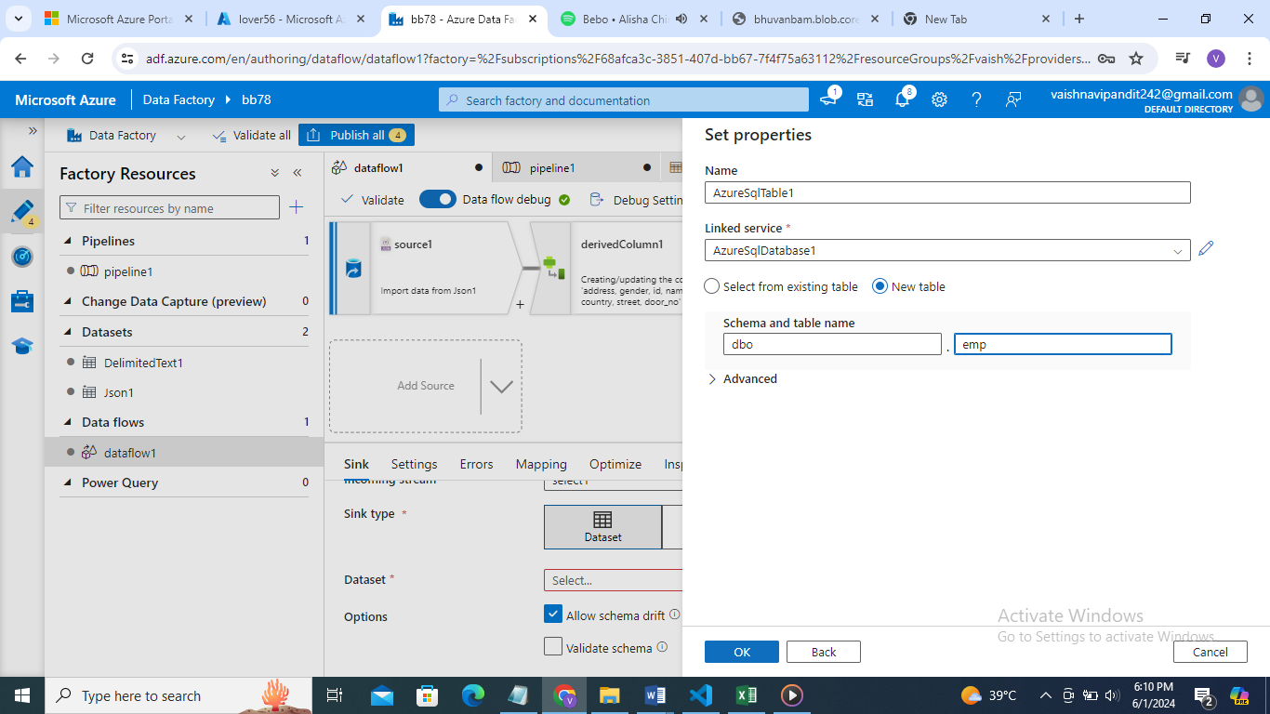

1. Now create pipeline

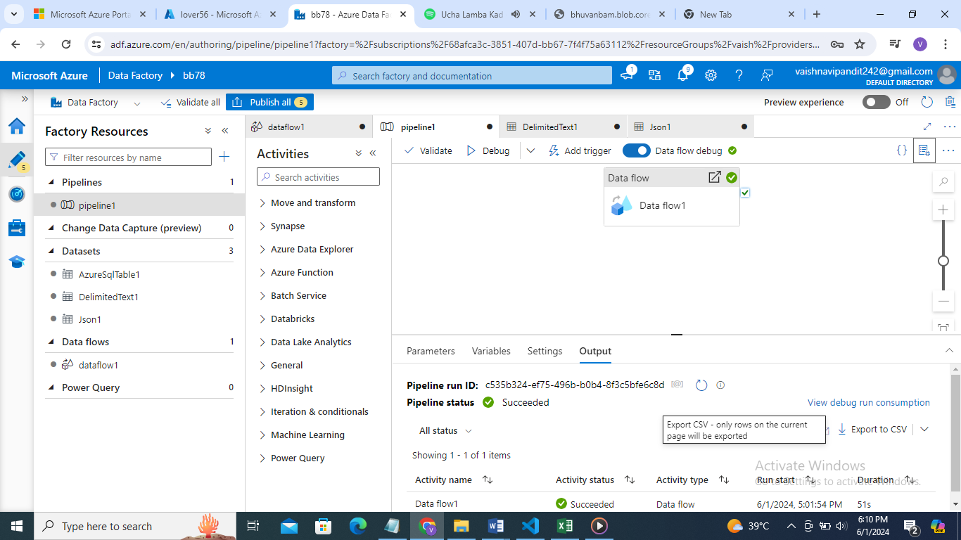

1. Debug